IBM Watson IoT Platform

Create IBM Watson IoT Platform service

<https://cloud.ibm.com/docs/IoT/index.html>

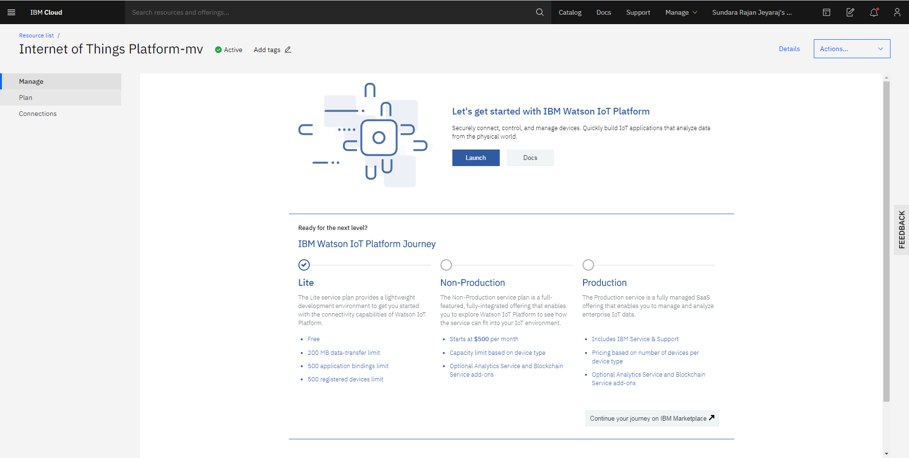

Add devices

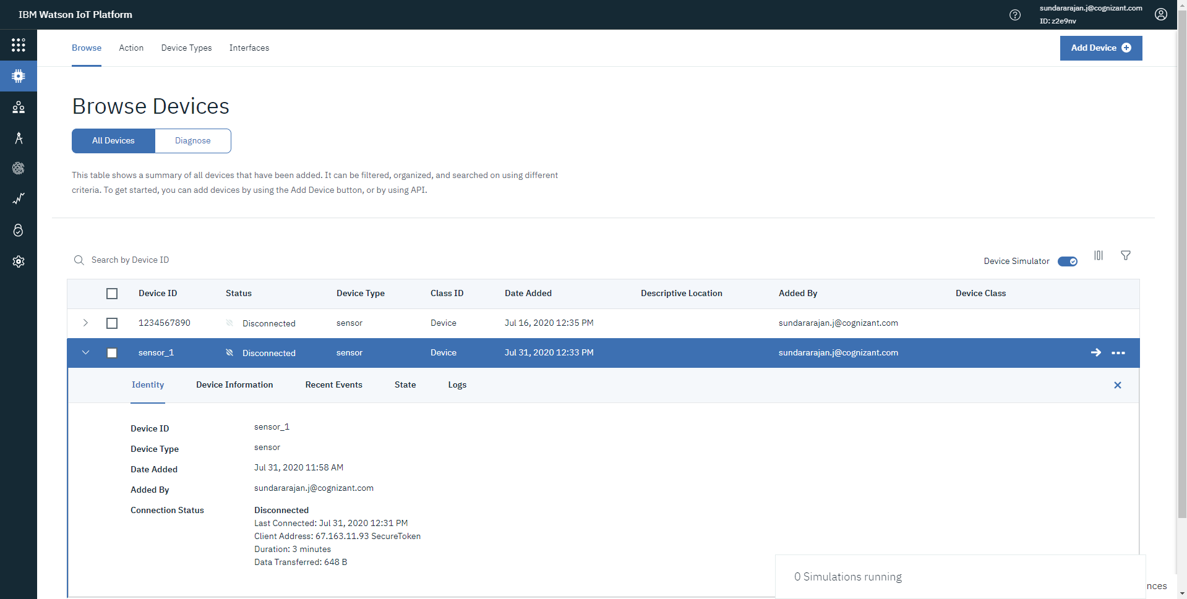

Create Simulation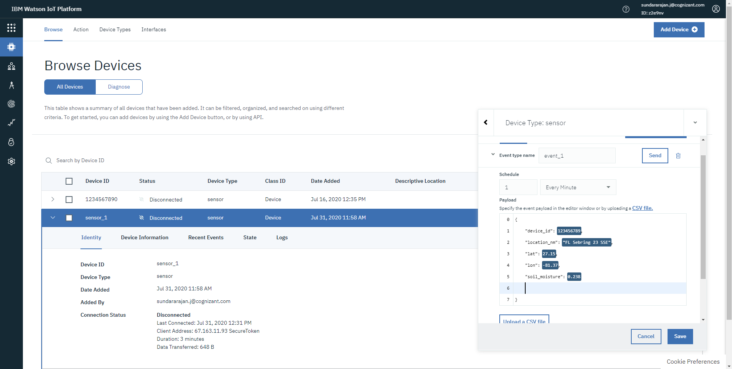

Create connection to Node RED Cloud Foundry Application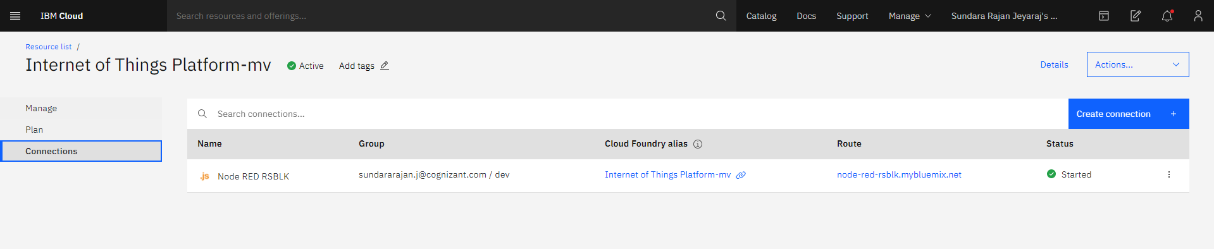

Once Connection is created an API key will be generated